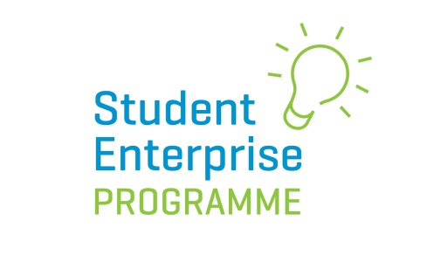
NEW Senior Cycle ‘ Creative Business Idea Award’ introduced for 2019/20 Programme
In 2019/20 the Student Enterprise Programme is launching an exciting new competition for senior cycle students, which will run alongside the mini company programme.
The Local Enterprise Offices are very focused on driving innovative and creative thinking in schools and to this end are inviting students over 16 years of age who are already taking part in the Student Enterprise Mini-Company Programme, to enter this ‘Creative Business Idea Award’.
Here’s how it works:
- Students MUST BE OVER 16 YEARS of age and in SENIOR CYCLE to enter.
- Entries must be on an individual basis ONLY.
- To qualify to enter a student must be part of a class that is signed-up to do the Student Enterprise Programme (senior category) at school.
- The business idea being used for the main Student Enterprise Programme (mini company) cannot be used as the idea for this new award. The idea for this new award must be entirely separate.
- Students must come up with an innovative new business idea based around the theme of ‘Go Green; Be Sustainable’. The theme will change from year to year.
- Students DO NOT have to have a prototype or product made/sold to take part in this competition – it is purely concept based and students will be judged on the innovation of their idea.
- Students must make a short 2 minute video (maximum length) outlining what their business idea is and how it works.
- The video can be submitted online via a link from the www.studententerprise.ie website. Please keep an eye on our website for information on the deadline for submission and also for tips on how to structure your video entry. Students must have a special password in order to submit their video which can be obtained from their teacher.
- A winner will be chosen from each participating Local Enterprise Office region and this entry will go forward to be considered for the National Creative Business Idea Award 2020, which will be announced our National Final in May 2020. The prize for the Overall National Winner is a 500 euro voucher.

For further information on this exciting new innovation competition and deadlines for entry please see www.studententerprise.ie

