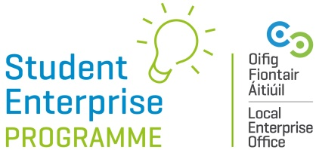

20/21 Creative Business IDEA Video Competition

The ‘Creative Business Idea’ Video Competition will make a return to our 20/21 programme line-up.
The idea behind this competition is to encourage creative thinking and innovative among students, without students having to actually produce a product or prototype.
ENTRIES ON IN NOVEMBER
Here’s How It Works:
-Students must come up with an innovative new business idea based around the theme of ‘COVID-19 Innovations’. Business ideas must fall within the remit of ‘COVID-19’.
-Business ideas are only eligible if they fall within the category of COVID-19 innovations.
-Students DO NOT have to have a prototype or product made/sold to take part in this competition – it is purely concept based and students will be judged on the innovation of their idea.
-Students must make a short 2 minute video (maximum length) outlining what their business idea is and how it works. Any student appearing in the video clip must also be over 16 years of age at the time of appearing in the video. The video clip should be uploaded to the student’s You Tube account and put on a ‘public setting’.

Rules & Regulations:
-Students MUST BE OVER 16 YEARS of age at the time of entry and in SENIOR CYCLE to enter. Anyone appearing in the pitch video must also have been 16 years old or older at the time the pitch video was made.
-Entries must be on an individual basis ONLY.

-To qualify to enter a student must be signed-up for the Student Enterprise Programme (senior category) at their school.
-The business idea being used for the main Student Enterprise Programme (mini company) cannot be used as the idea for this new award. The idea for this new award must be entirely separate.
-Entry deadline: 28th February 2021.
-Entries in each of the different LEO regions/counties will be judged at local level initially and one winner chosen to be put forward for the National Creative Business Idea Award 2021, which will be announced our National Final 2021. The prize for the Overall National Winner is a 500 euro voucher.

ENTRIES OPEN IN NOVEMBER

