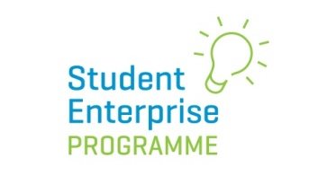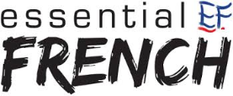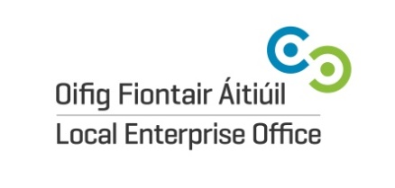

2020 SEP National Social Media Awards
The Student Enterprise Programme is delighted to announce that we will once again be awarding three prizes in the area of social media at the National SEP Final on Friday 1st May 2020 in Croke Park, Dublin.
The awards are kindly sponsored by Essential French, Cork (www.essentialfrench.ie) and are open to all students nationwide taking part in the SEP 19/20, not just those who make the National Final.
Students will be judged on their performance on various social media platforms for their student enterprises over the course of the year – how well they interacted with their customers on social media, how creative they were with their social media campaigns and how they maximized social media for the betterment of their enterprises.

Award Categories:
- Most Effective Social Media Campaign 250 euro prize
In this category the judges will be looking at the different tools available to use on social media (ie polls, FB lives, IGTV, highlights).

- Most Creative Use of Social Media 250 euro prize
In this category the judges will be looking at the ways that the students’ social media accounts are being used (i.e. unusual ways of using the tools available to promote their product / company).

- Most Interactive Business on Social Media 250 euro prize

In this category the judges will be looking at how the followers engage with each account (ie feedback, reviews, competitions).
How to Enter:
To enter, simply complete the entry form on our website and return to the address provided below by Wednesday 1st April 2020:

Yvonne O’Neill
National Student Enterprise Co-ordinator
c/o: Local Enterprise Office, Cork City
Room 101, Ground Floor
City Hall Building
Anglesea Street
Cork City

Please note: The social media awards are marked independently of the main marking scheme at the SEP National Final and therefore student enterprises that do not operate social media accounts for their business are not disadvantaged in any way as a result.
The judges will base their marking only on posts made on social media from the start of the current academic year 2019/20. Posts and social media interactions before this date will not be included in judging process.

