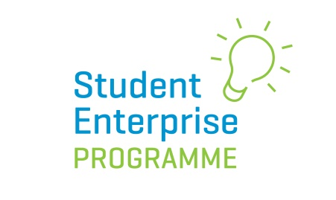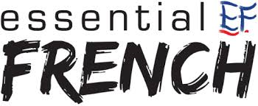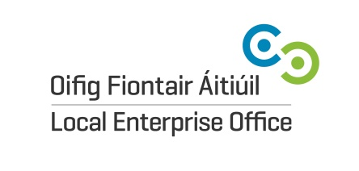

2020 National Social Media Awards Entry Form

Name of Student Enterprise: ………………………………………………………………………………………….
Account Details Number of followers/views/likes
Instagram ………………………………… ……………………………………………………….
Snapchat ………………………………… ……………………………………………………….
Twitter ………………………………… ……………………………………………………….
Facebook ………………………………… ……………………………………………………….

Give a description of your student enterprise mini-company (50 words approx.)?

…………………………………………………………………………………………………………………………………………………………………………………………….
…………………………………………………………………………………………………………………………………………………………………………………………….
…………………………………………………………………………………………………………………………………………………………………………………………….
…………………………………………………………………………………………………………………………………………………………………………………………….
…………………………………………………………………………………………………………………………………………………………………………………………….
…………………………………………………………………………………………………………………………………………………………………………………………….
…………………………………………………………………………………………………………………………………………………………………………………………….
…………………………………………………………………………………………………………………………………………………………………………………………….
…………………………………………………………………………………………………………………………………………………………………………………………….

What strategy on social media worked best for you to engage your potential customers and why?
(please use additional page if necessary)
…………………………………………………………………………………………………………………………………………………………………………………………….
…………………………………………………………………………………………………………………………………………………………………………………………….
…………………………………………………………………………………………………………………………………………………………………………………………….
…………………………………………………………………………………………………………………………………………………………………………………………….
…………………………………………………………………………………………………………………………………………………………………………………………….
…………………………………………………………………………………………………………………………………………………………………………………………….
…………………………………………………………………………………………………………………………………………………………………………………………….
…………………………………………………………………………………………………………………………………………………………………………………………….
…………………………………………………………………………………………………………………………………………………………………………………………….
Please submit this completed form in an envelope marked ‘National Social Media Award Entry’ and post to: Yvonne O’Neill, National Co-ordinator, Student Enterprise Programme, c/o: Local Enterprise Office, Cork City, Room 101, Ground Floor, City Hall, Anglesea Street, Cork City by Wednesday 1st April 2020.

.

