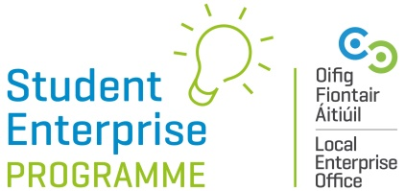

21/22 Creative Business IDEA Video Competition

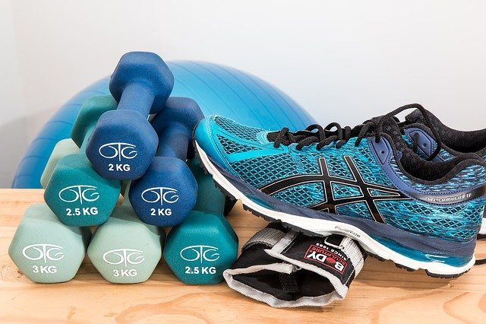
The ‘Creative Business Idea’ Video Competition will make a return to our 21/22 programme line-up.
The idea behind this competition is to encourage creative thinking and innovative among students, without students having to actually produce a product or prototype.
ENTRIES ON IN NOVEMBER
Here’s How It Works:
-Students must come up with an innovative new business idea based around the theme of ‘Fitness & Wellbeing’. Business ideas are only eligible if they fall within the remit of ‘Fitness & Wellbeing.
-Students DO NOT have to have a prototype or product made/sold to take part in this competition – it is purely concept based and students will be judged on the innovation of their idea.

-This year the competition is open to BOTH junior cycle and senior cycle students.

Junior Cycle Students: (Under 16 years old at time of entry)

- Students must make a short 2 minute video (maximum length) outlining what their business idea is and how it works.

- Junior category students’ videos should not feature individuals, either themselves or others. The video should showcase only props/graphics/animation/narration etc… to pitch their idea, as students are under 16 years of age.

- The students can fill in the entry form and attach their video via a link on our SEP website which will be live from November 2021.

- Deadline for entry is 28th February 2022.

- Parental consent is required.
Senior Category (16 years and over at time of entry):

- Students must make a short 2 minute video (maximum length) outlining what their business idea is and how it works.

- Any student appearing in the video clip must also be over 16 years of age at the time of appearing in the video.

- Students will be able to complete the online entry form and submit their video on the SEP website from November 2021.

- Deadline is 28th February 2022.

Rules & Regulations:
- Students must be in the relevant age category at the time of entry.

- Entries must be on an individual basis ONLY.

- To qualify to enter a student must be signed-up for the Student Enterprise Programme at their school.
- The business idea being used for the main Student Enterprise Programme (mini company) cannot be used as the idea for this new award. The idea for this new award must be entirely separate.
- All entries must be received by 28th February 2022 at 5pm.
- Entries in each of the different LEO regions/counties will be judged at local level initially and one winner chosen to be put forward for the National Creative Business Idea Award 2022, which will be announced our National Final. The prize for the Overall National Winner in each category is a €500 voucher.

ENTRIES OPEN IN NOVEMBER
