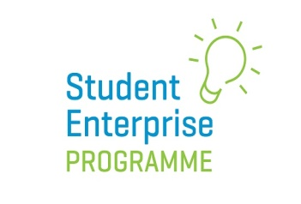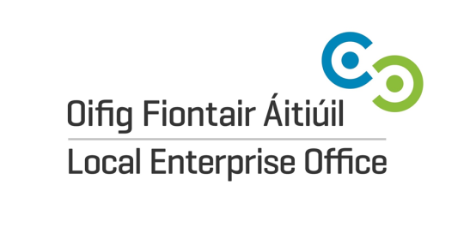
2022 National Final Entry Pack
SECTION 1: School Detail
Business Name:

Business Description
(max 20 words):

School Name & Address:
Teacher Name, Contact Number & Email:
County/LEO Area:
Category (please tick) Junior (1st year)

Intermediate (2nd & 3rd year)

Senior (TY, 4^{th,} 5th, 6th year, LCA, LCVP, Youthreach*)

Student Names 1.
2. 3.
4. 5.

*Please note: A max of only 5 students can represent a team at National Final live event. Youthreach students – each member of a team must be no older than 18 years on the day of the National Final.
Data Protection:
The Local Enterprise Office is committed to its transparency obligations under the General Data Protection Regulation (GDPR). Our data protection notice for personal data that is supplied to us by our clients is available at www.localenterprise. ie/legal. This notice contains important information about how we process personal data that is supplied to us by clients. We request that you read the notice carefully and that you ensure that it is made available to any data subjects (e.g. your students) whose personal data you provide to us.
By ticking “I agree”, you confirm that: (a) you have complied with your own data protection obligations in respect of the personal data that you supply to us and that you are entitled to disclose such personal data to us; and (b) you will ensure that a copy of our data protection notice is sent to data subjects (e.g. your students) whose personal data you provide to us.

I agree

Signed by teacher: …………………………… Date: ……………………..

SECTION 2: Commencement of Trading Declaration

Senior Category:
I hereby confirm that the above-named student enterprise did not begin trading before September of the current academic year. I understand that any student enterprise participating at the National Final that displays evidence of sales before the beginning of the current academic year will be automatically disqualified.

LEO Student Enterprise Co-ordinator Signature:

…………………………………………………………………………………

Junior & Intermediate Category:
I hereby confirm that the above-named student enterprise did not carry out any trading of the product/service they are entering into the 2021/22 competition before September of the current academic year. I understand that any student enterprise participating at the National Final that displays evidence of sales before the beginning of the current academic year will be automatically disqualified.

LEO Student Enterprise Co-ordinator Signature:

…………………………………………………………………………………

SECTION 3: Photography/Videography Permission

Students over 16 years of age:
I hereby confirm that I give full permission for the 2-minute pitch video that accompanies my entry to be used by the Student Enterprise Programme in an educational/promotional showreel for the Programme. I understand that this video/imagery may be used for such purposes on the SEP website, on SEP social media channels and across other promotional and educational channels operated by the network of Local Enterprise Offices.
I also give my full permission to appear in any videography/photography taken at the live National Final 2022 and for such footage to be used in SEP promotional/educational materials/channels.

Signed: …………………………………………………..
…………………………………………………..
…………………………………………………..
…………………………………………………..
…………………………………………………..
…………………………………………………..
…………………………………………………..
…………………………………………………..
…………………………………………………..
…………………………………………………..

Student name

Students under 16 years of age:
I hereby confirm that, as the parent/legal guardian, I give full permission for the 2-minute pitch video that accompanies my son/daughter’s entry to be used by the Student Enterprise Programme in an educational/promotional showreel for the Programme. I understand that this video/imagery may be used for such purposes on the SEP website, on SEP social media channels and across other promotional and educational channels operated by the network of Local Enterprise Offices.
I also give my full permission for my son/daughter to appear in any videography/photography taken at the National Final 2022 and for such footage to be used in SEP promotional/educational materials.

Signed:

……………………………… ………………………………
……………………………… ………………………………
……………………………… ………………………………
……………………………… ………………………………
……………………………… ………………………………
……………………………… ………………………………

Signed by parent/guardian on behalf of Student name

