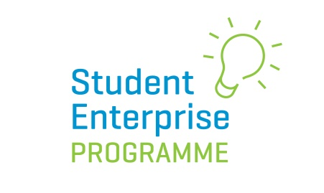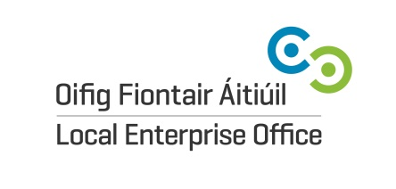

2022/23 National Social Media Awards Entry Form

Name of Student Enterprise: ………………………………………………………………………………………….

Account Details Number of followers/views/likes
Instagram ………………………………… ……………………………………………………….
Snapchat ………………………………… ……………………………………………………….
Twitter ………………………………… ……………………………………………………….
Facebook ………………………………… ……………………………………………………….
Tik Tok ………………………………… ……………………………………………………….

What strategy on social media worked best for you to engage your potential customers and why?
(please use additional page if necessary)
…………………………………………………………………………………………………………………………………………………………………………………………….
…………………………………………………………………………………………………………………………………………………………………………………………….
…………………………………………………………………………………………………………………………………………………………………………………………….
…………………………………………………………………………………………………………………………………………………………………………………………….
…………………………………………………………………………………………………………………………………………………………………………………………….
…………………………………………………………………………………………………………………………………………………………………………………………….
…………………………………………………………………………………………………………………………………………………………………………………………….
…………………………………………………………………………………………………………………………………………………………………………………………….
…………………………………………………………………………………………………………………………………………………………………………………………….
Please submit this completed form via email to nationalcoordinator@studententerprise.ie by 31st March 2023.

