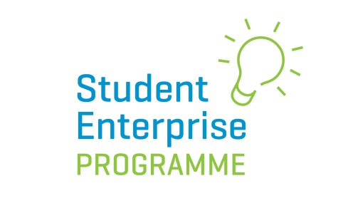
Go Green: Be Sustainable: Most Creative Business Idea Competition 2019/20
In 2019/20 the Student Enterprise Programme is launching an exciting new competition for senior cycle students, which will run alongside the mini company programme.
The Local Enterprise Offices are very focused on driving innovative and creative thinking in schools and to this end are inviting students over 16 years of age who are already taking part in the Student Enterprise Mini-Company Programme, to enter this ‘Creative Business Idea Award’.

How the Competition Works:
- Students MUST BE OVER 16 YEARS of age at the time of entry and in SENIOR CYCLE to enter.
- Entries must be on an individual basis ONLY.
- To qualify to enter a student must be part of a class that is signed-up to do the Student Enterprise Programme (senior category) at school.
- The business idea being used for the main Student Enterprise Programme (mini company) cannot be used as the idea for this new award. The idea for this new award must be entirely separate.

Students must come up with an innovative new business idea based around the theme of ‘Go Green; Be Sustainable’. Business ideas must fall within the remit of ‘Go Green: Be Sustainable’. Business ideas are only eligible if they fall within the category of renewables, environmentally friendly, address the issue of climate change, sustainability, marine etc…
- Students DO NOT have to have a prototype or product made/sold to take part in this competition – it is purely concept based and students will be judged on the innovation of their idea.
- Students must make a short 2 minute video (maximum length) outlining what their business idea is and how it works. Any student appearing in the video clip must also be over 16 years of age (at the time of appearing in the video). The video clip should be uploaded to the student’s You Tube account and put on a ‘public setting’.
- In early November 2019 the application form will be available on our website. Students should fill in the online form and provide the live link to their YouTube video for judging.

- Entries in each of the different LEO regions/counties will be judged at local level initially and one winner chosen to be put forward for the National Creative Business Idea Award 2020, which will be announced our National Final in May 2020. The prize for the Overall National Winner is a 500 euro voucher.

For further information please contact your Local Student Enterprise Co-ordinator or Local Enterprise Office.

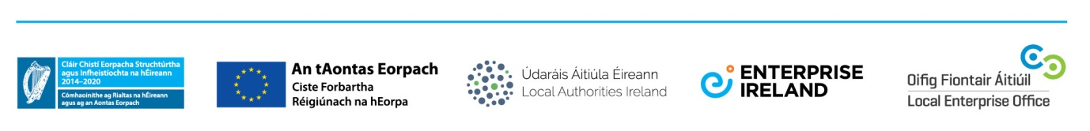
Marking Scheme

All video entries should be assessed using the following criteria at County Level:
- Innovation of Business Idea: 75 Marks
-What is innovative about the proposed product/service?
-Has any research into Intellectual Property been carried out?
-Are there any similar ideas already on the market? If so, why is this idea better?

- Market Opportunity: 10 Marks
-What, if any, market research was carried out?
-What evidence is there that the proposed product/service meets a need?
-Size of potential market?
-Competitor analysis carried out?
- Presentation & Pitching Skills: 15 Marks
-Is the pitch well thought out?
-Is it concise and to the point?
-Does it clearly explain what the product or service is about and the USPs?
-Does it demonstrate the passion of the applicant for the idea?

Total Marks: 100

Tips For Students
- Video MUST strictly be no longer than maximum 2 minutes in length.
- Keep it short, to the point and impactful!
- Your video pitch should clearly answer the following questions:

-What is the business idea?

-What problem does it solve and how does it work?

-Why is your idea innovative?

-Who do you think will buy/use your idea and why?

-Who are your competitors? Why is your idea better?
- Try to grab the judges’ attention in the first few seconds – how can you stand out?
- The judges will want to see you are passionate about your idea so this should shine through in your pitch.
- Make sure you do plenty of practice before making the final cut!
- Although this competition is based on individual and not group entries, it’s always a good idea to get some help in the production of the video. Ask a friend or family member to five you some feedback during the production.
- Make sure you choose a quiet place to record with no background noise and to ensure sound quality is good.
- Anyone in video must be over 16 years of age.

