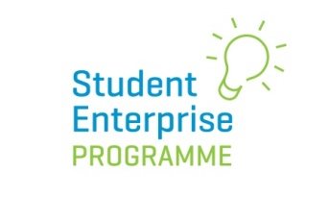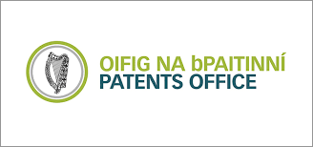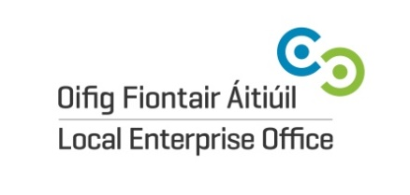

2020 SEP National Intellectual Property Awards
The Student Enterprise Programme is delighted to announce that we will once again be awarding three prizes in the area of Intellectual Property at the National SEP Final on Friday 1st May 2020 in Croke Park, Dublin.
The awards are kindly sponsored by The Irish Patents Office (www.patentsoffice.ie) and are open only to students taking part in the National Final 2020.
Students will be judged on their understanding of the area of IP for business and how they considered the various IP issues in relation to their own student enterprises. For example, how a team researched the uniqueness of their brand, identified IP rights owned by others that they need to request permission for, and if and how they have looked into how to protect their own IP for their student enterprise.

Award Categories:
• Intellectual Property Award (Junior Category) 200 euro
• Intellectual Property Award (Intermediate Category) 250 euro
• Intellectual Property Award (Senior Category) 300 euro

How to Enter:
To enter, students must include a section on Intellectual Property in their business report submitted for the National Final which must be submitted by Wednesday 1st April 2020.

