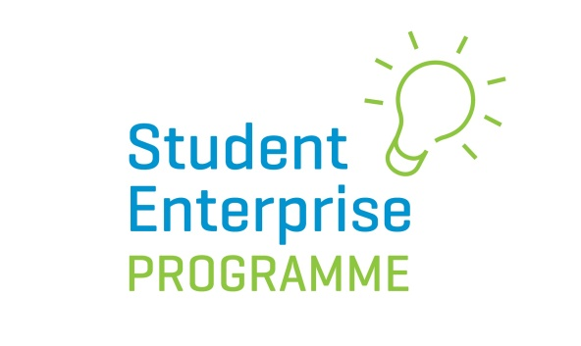

Most Creative Business Idea Video Competition 2020/21

Marking Scheme

- Innovation of Business Idea: 75 Marks
-What is innovative about the proposed product/service?
-Has any research into Intellectual Property been carried out?
-Are there any similar ideas already on the market? If so, why is this idea better?

- Market Opportunity: 10 Marks
-What, if any, market research was carried out?
-What evidence is there that the proposed product/service meets a need?
-Size of potential market?
-Competitor analysis carried out?
- Presentation & Pitching Skills: 15 Marks
-Is the pitch well thought out?
-Is it concise and to the point?
-Does it clearly explain what the product or service is about and the USPs?
-Does it demonstrate the passion of the applicant for the idea?

Total Marks: 100

