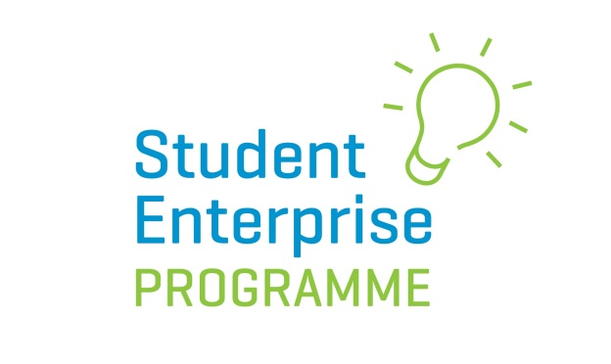

My Entrepreneurial Journey Competition

The Student Enterprise Programme is running a new pilot competition for Junior Cycle students in 2019/20. The aim of this competition is to give students a fun and easy way to learn about life as an entrepreneur while using their imagination.

Here’s how it works …

- Students get to imagine their life as an entrepreneur at a future stage of their life – it can be in 5 years, 10 years or 40 years’ time! They must imagine themselves as having set up a business and been on an entrepreneurial journey and they will tell us the story of their fictitious business, highlighting what they learned about being an entrepreneur on the way.
- Students must complete 3 elements to enter the competition:

- (1) They must write an account of their entrepreneurial life story in no more than 500 words, including detail such as:

-The area of business they went into
-The business/product/service name
-Why they became an entrepreneur
-The ups and downs along the way
-Lessons learned, challenges overcome etc …. (see attached Reflection Template)

(See attached guidelines for full details of what to include)
(2) Students must also produce an A3 poster as a visual display/storyboard of their imagined entrepreneurial journey. This should be the story of their business or a 10 point enterprise plan (as per attached example of poster).

(3) As part of the project students must also interview a local entrepreneur in the community to learn about what is involved in setting up and running a company and write a one page account of this. This should include desk and field research, list of interview questions and a summary of what you learned.

- The business the students imagine themselves setting up does not have to be based on an entirely new idea. It can be a shop, restaurant, online business etc… anything they wish.
- The focus of this competition and of judging is not on how creative or innovative the business is. We are looking for what students learned about what it takes to be an entrepreneur, obstacles faced, pitfalls, advantages etc…..
- Entries will be judged at County level and one entry from Junior category and one from Intermediate category will be chosen to go forward to compete for a national award.
- Please note: this is a pilot programme and not all Local Enterprise Office regions may take part. Please check with your Local Enterprise Office to see if this competition is being run in your area.

Competition Rules:

- Students must enter as individuals rather than teams.
- To qualify to enter a student must be part of a class that is signed-up to do the Student Enterprise Programme (junior or intermediate category) at school.
- Competition is open to all students from 1st year to 3rd year under the following categories:

Junior category: 1st year students
Intermediate category: 2nd and 3rd years
- Students must submit their completed entry by the designated deadline with the accompanying cover sheet.
- Posters should be A3 in size. Posters can be made up by the students themselves for the County round, but must be printed professionally should they progress to national stage.
- Judges decision is final.

Prizes:

- The prizes will be as follows for both junior and intermediate categories AT NATIONAL LEVEL:

1st^{t} place: 500 euro voucher + certificate + trophy
2nd place: 250 euro voucher + certificate + trophy
3rd place: 250 euro voucher + certificate + trophy
How to Enter:

The written report, business poster and entrepreneur interview report should be submitted to the Local Enterprise Office/Schools Enterprise Co-ordinator by the designated deadline.

Guidelines/Marking Scheme:
- Account of their entrepreneurial life story: 50%
- Poster (A3 storyboard or 10 point enterprise plan): 40%
- Interview with an entrepreneur: 10%

Guidelines for Submissions:

- Each submission should be accompanied by the cover sheet provided.
- Students should write their “imagined” entrepreneurial story in no more than 500 words. Students are welcomed to submit sketches, drawings
etc… with their written application.

- Typed submissions are preferable.

- Posters should be A3 in size.

Areas of their entrepreneurial story the students should touch on include:

-How they came up with the business idea? What attracted them to this type of business?
-Who the business was targeted at?
-Where they got their start-up capital from?
-What type of market research did they carry out?
-Why they felt they were suited to life as an entrepreneur? What skills they felt they had and what ones they had to work on?
-Main obstacles and challenges they faced?

-Why did they decide to become an entrepreneur?
-Best and worst parts of life as an entrepreneur?
-What, if any, skills they brought into the business by recruiting staff?
-Threats and weaknesses of the business?
-If the business idea was patented or there were any IP considerations?
-How the business was marketed and promoted?
-How did you come up with your pricing?

-Most important lessons learned

-Have you changed your opinion of entrepreneurship after doing this project?

Note: the above points could also be used as questions to ask the chosen entrepreneur being interviewed.

Interview with an Entrepreneur

Top Ten Suggested Questions:

1. Entrepreneur Name: Enterprise:
2. Explain how you generated your enterprise idea.
3. What skills and qualities do you think an entrepreneur should have?
4. What research did you do?
5. Can you explain your Marketing Mix?
Product
Price
Place
Promotion
Packaging
6. What are the benefits and challenges of running your own enterprise?
7. Does your enterprise sell in other countries and what are the challenges?
8. Have you received any support financially?
9. How do you impact on your local community?
10. What advice would you give me if I were to set up an enterprise?

The above are suggested questions only.

Template Reflection on My Entrepreneurial Journey

[This takes place after completion and after making a presentation.]

- Title of your enterprise journey:
- What new knowledge you learned as a result of taking part in this journey?
- Explain why you feel this new knowledge is important?
- Explain how your opinion on enterprise has changed as a result of completing presentation on My Entrepreneurial Journey.
- How might you improve your presentation skills?

Example of Poster:

