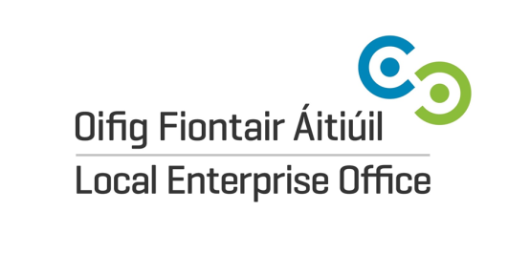
My Entrepreneurial Journey
Entry Form 21/22
Student Name:

Name of ‘business’:
School Name & Address:
Teacher Name, Contact Number & Email:

County/LEO Area:
Category (please tick) Junior (1st year)

Intermediate (2nd & 3rd year)
Attachments (please tick) - Entrepreneurial Story (500 words max.)

-A3 Poster

-Entrepreneur Interview (one page only)

Data Protection:
The Local Enterprise Office is committed to its transparency obligations under the General Data Protection Regulation (GDPR). Our data protection notice for personal data that is supplied to us by our clients is available at www.localenterprise. ie/legal. This notice contains important information about how we process personal data that is supplied to us by clients. We request that you read the notice carefully and that you ensure that it is made available to any data subjects (e.g. your students) whose personal data you provide to us.
By ticking “I agree”, you confirm that: (a) you have complied with your own data protection obligations in respect of the personal data that you supply to us and that you are entitled to disclose such personal data to us; and (b) you will ensure that a copy of our data protection notice is sent to data subjects (e.g. your students) whose personal data you provide to us.

I agree

Signed by teacher: …………………………… Date: ……………………..

