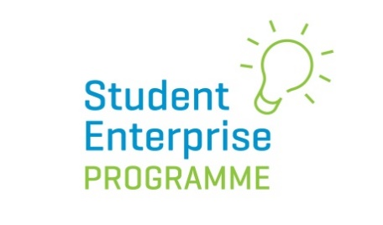

How the new
Student Enterprise Programme (SEP)
Supports the
Junior Cycle Business Studies Specification

A Teacher’s Guide

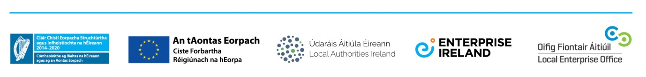
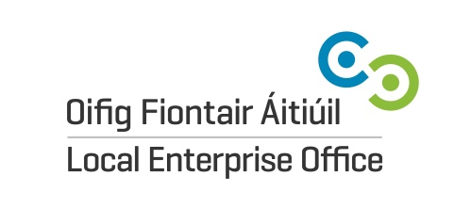
How the new SEP works with Junior Cycle Business Studies

The Local Enterprise Offices have re-vamped their Student Enterprise Programme Junior Cycle Programme in 19/20 to work in tandem with the new Junior Cycle Business Studies specification.
This booklet outlines how the new SEP works and how it can be used by teachers in the delivery of Junior Cycle Business Studies.
“Our newly designed programme supports the new Junior Cycle Business Studies specification. The emphasis is on research, skills & reflection”
The purpose of the newly revamped Student Enterprise Programme for junior cycle is to support and improve learning. It is designed to encourage students to reflect on their learning.
There are two key elements to the new SEP Junior Cycle Programme:
- Mini-company:
Students, either individually or in a group, establish and operate an enterprise, with the emphasis being on reflection and skills. Students must produce a reflective business poster at the end of the Programme outlining their business journey (see sample on page 9).
- My Entrepreneurial Journey Competition
Students individually, as part of a new competition, get to imagine their life as an entrepreneur in the future, with the emphasis being on what they learned. As part of this project, students must interview a local entrepreneur in their community.
A separate leaflet outlining how the ‘My Entrepreneurial Journey Competition’ works is also available from your Local Schools Enterprise Co-ordinator and on our website www.studententerprise.ie
Our newly designed programme supports the new Junior Cycle Business Studies specification. The emphasis is on research, skills & reflection. It affords business teachers to teach through the lens of the new specification.

Junior Cycle Business Studies Specification

Entrepreneurship enhances the quality of our collective and our individual lives, often changing the way we work, volunteer, communicate and actually live.

Enterprise is an integral part of the Junior Cycle Business Studies. The Junior Cycle Business Studies provides an awareness, insight and positive attitude to entrepreneurship, demonstrating how it can improve our lives, adding value to goods, services and all the add on effects on institutions. It also supports the expansion of analytical and critical thinking skills, encouraging students to be problem solvers. It reinforces the development of students’ numeracy, literacy and digital technology skills by providing a real-life context for their application. Students will develop a ‘can do’ attitude and this subject will help them to fulfil their potential in their personal and professional lives, both now, as a student and into the future as a responsible citizen.
The dynamic and energetic world of Business Studies is brought to life in the classroom through learning about the business world and the economy and how they impact on our daily lives. The specification for Junior Cycle Business Studies has three interconnected strands.
Junior Cycle Business Studies – 3 Interconnected Strands
PERSONAL
FINANCE
ENTERPRISE
OUR
ECONOMY

- Personal Finance: focuses on students making informed decisions to effectively and responsibly manage their financial resources.
- Enterprise: encourages students to identify opportunities and develops an understanding of the financial, marketing and operational functions of an organisation.
- Our Economy: enables students to understand the dynamic relationship between the local, national and international economic situation.

Student Enterprise Programme not mean doing something extra.

Students taking part in the Student Enterprise Programme will have the opportunity to develop all key skills

The Following are the 8 Junior Cycle Key Skills:
- Being Literate  - Managing Myself  - Staying Well  - Managing Information and Thinking  - Being Numerate  - Being Creative  - Working with Others  - Communicating | 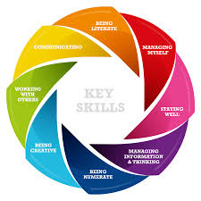

Learning Outcomes
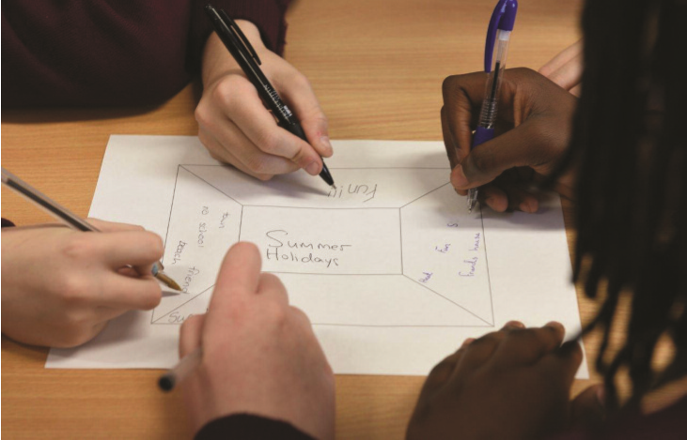
There are 37 learning outcomes across the 3 strands. Learning outcomes describe the knowledge and understanding, skills and values that students should be able to demonstrate after participating in Business Studies.
By using the Student Enterprise Programme students will achieve numerous learning outcomes, which are highlighted in the table below Junior Cycle Business Studies Specification Table

Strand 1 | 1.1 | 1.2 | 1.3 | 1.4 | 1.5 | 1.6 | 1.7
Personal  Finance | Personal resources | Income and expenditure | Personal Financial life cycle | Key personal taxes | Savings | Insurance | Rights and responsibilities of consumer
 | ✓ | ✓ |  |  |  |  | ✓
 | 1.8 | 1.9 | 1.10 | 1.11 | 1.12 | 1.13
 | Services: Consumer Agencies and financial institutions | Ethics and sustainability consumption | Globalisation, technology consumer choice. | Wage Slip | Budget | Income and Expenditure and bank Statement
 |  | ✓ | ✓ |  |  | ✓
Strand 2 | 2.1 | 2.2 | 2.3 | 2.4 | 2.5 | 2.6 | 2.7
Enterprise | Financial, Social and Cultural Enterprise Roles | Employment, Work and Volunteerism | Employment, Work and Volunteerism | Rights and Responsibilities: Employers and Employees | Organisations’ Positive and Negative Impacts on Communities | Digital Technology: Benefits and Costs | Market Research
 | ✓ |  |  |  |  | ✓ | ✓
 | 2.8 | 2.9 | 2.10 | 2.11 | 2.12 | 2.13
 | Marketing Mix | Business Plan | Key Business Documents | Cash Flow Forecast/Budget | Cash Book, Ledger and Trial Balance | Final Accounts
 | ✓ | ✓ |  | ✓ | ✓ | ✓
Strand 3 | 3.1 | 3.2 | 3.3 | 3.4 | 3.5 | 3.6 | 3.7
Our  Economy | Scarcity and Choice | Circular flow of income | Supply and Demand | Government Revenue and Expenditure | Taxation | Positive and Negative Economic Growth and Sustainability | Globalisation of Trade
 |  |  | ✓
 | 3.8 | 3.9 | 3.10 | 3.11
 | European Union – Benefits and Challenges | Economic Indicators | Economic Issue | Government Policy
 | 3.1 | 3.2 | 3.3 | 3.4
Junior Cycle Business Studies Specification Table
The Learning Outcomes highlighted below are directly related to the Student Enterprise Programme.

Note: Continue to revisit the Learning outcomes.
Assessment
The Student Enterprise Programme provides students with an opportunity to take the learning experience outside the classroom as they identify opportunities and convert them into practical businesses.

Assessment and the Student Enterprise Programme:
By participating in the Student Enterprise Programme students are given the opportunity to:
- Achieve numerous learning outcomes
- Develop all the key Junior Cycle skills
- Be supported for preparation for Classroom Based Assessment
- Be well prepared for the Final Examination

Classroom-Based Assessments (CBAs):
SEP WILL SUPPORT ALL ELEMENTS OF ASSESSMENT OF JUNIOR CYCLE (INCLUDING CBAs)

The Student Enterprise Programme will support the CBAs and is a superb way to help students on their learning Journey.
Remember, if CBA 1 is based on Enterprise it would be important to have a different theme for CBA2.
CBA 1: Business in Action: a group project towards end of 2nd Year.

- Students have a 4 week period to complete this CBA.
- It is to be completed in groups of 3 to 5 students.

There are three options to choose from:
- Enterprise in Action
- Economics in Action
- Finance in Action

CBA 2: Presentation: at end of first term in 3rd year.
- Students have a 3 week period to complete this CBA.
- Individual presentation of 3 minutes duration.
- Following CBA2, students complete a Reflective Assessment Task. The Assessment Task is assessed by the State Examinations Commission (SEC). It will be allocated 10% of the marks used to determine the final examination grade awarded by the SEC.

Finally, by participating in the SEP your students are supported in preparing for the final Junior Cycle Business Studies state-certified examination, which accounts for 90% of the total marks.

Guidelines & Marking Scheme:
Junior Category (mini-company programme)

PRODUCT/SERVICE
Quality of Product/Service | 5
Innovation | 5
PRODUCTION
Production Process | 5
MARKETING
Market Research | 10
Marketing Mix | 10
GLOBAL WORLD
Sustainability | 5
FINANCES
Cashflow Budget | 5
Sales/Profit | 5
ENTEPRISE POSTER PLAN
Design | 10
Content | 10
EXHIBITION STAND/INTERVIEW
Visual Display | 10
LEARNING EXPERIENCE
Skills Developed & Learned | 10
Lessons Learned | 10
FINAL SCORE | 100

Intermediate Category (mini-company programme)

PRODUCT/SERVICE | 40
Idea Generation/Innovation | 20
Quality of Product/Service | 20
PRODUCTION/SERVICE | 10
Process/Organisation | 10
MARKETING | 30
Market Research | 10
Marketing Mix | 10
Unique Selling Point (USP) | 10
GLOBAL WORLD | 10
Sustainability/Ethics | 10
FINANCES | 20
Cashflow Budget | 10
Sales/Profit | 10
ENTEPRISE POSTER PLAN | 30
Design | 10
Content | 10
Visuals | 10
EXHIBITION STAND/INTERVIEW | 10
Visual Display | 10
LEARNING EXPERIENCE | 30
Skills Developed & Learned | 10
Lessons Learned | 10
Problems/Challenges Overcome | 10
FINAL SCORE | 180

Sample Poster:

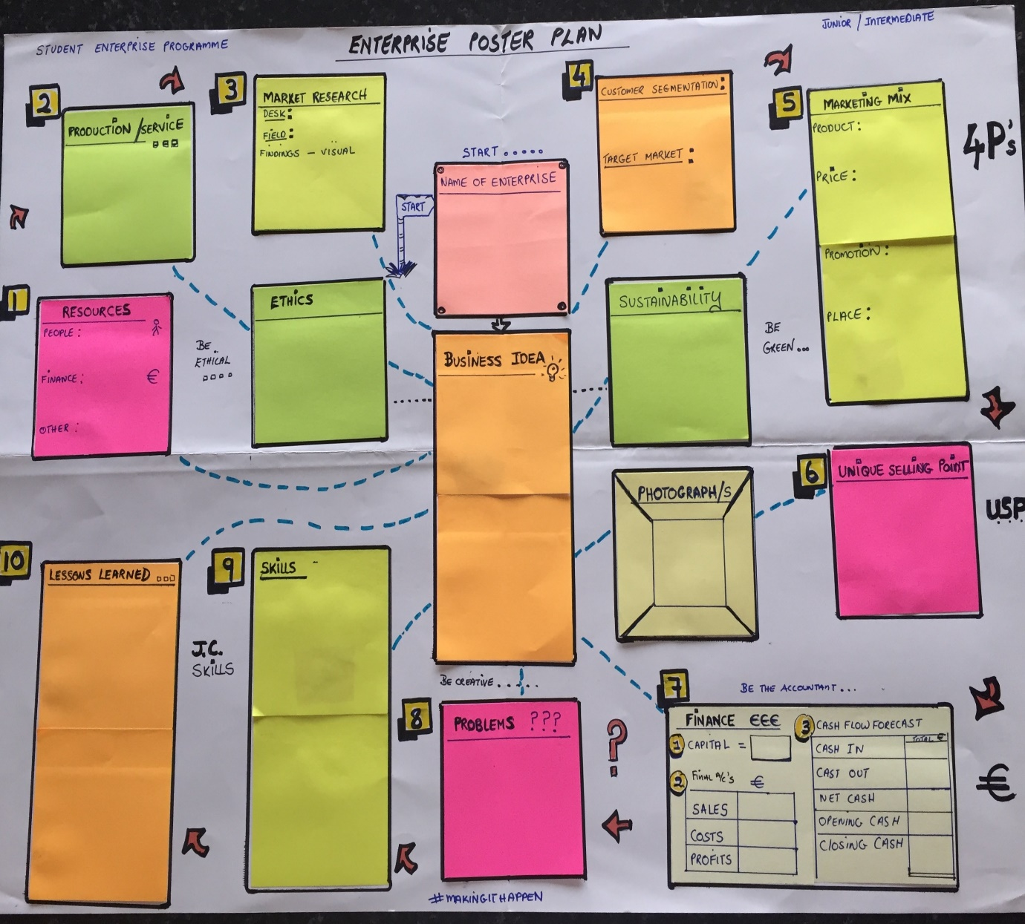
Resources
The Student Programme offers a suite of resources for students taking part in our Programme, including:
- Summary sheets covering every stage of running a student enterprise (available as pdfs on studententerprise.ie)
- Suite of videos on our YouTube Channel StudentEnterpriseIE
- Teachers’ Enterprise Handbook (available on our website)
- Support and school visits from your local Schools Enterprise Co-ordinator

Further Information
Further information is available at www.studententerprise.ie or from your Local Enterprise Office.

