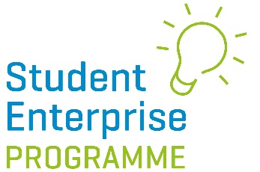

CREATIVE BUSINESS IDEA COMPETITION 2021/22

Parental Consent Form

Student Name: …………………………………………………………………

School: …………………………………………………………………

Year at School: …………………………………………………………………

I confirm that my son/daughter named above has my permission to enter the Student Enterprise Programme 2021/22 Creative Business Idea Competition and that he/she is fully aware of the terms and conditions of entry as outlined on the online entry form and that he/she complies with the entry requirements.

Parental Signature:

Date:

