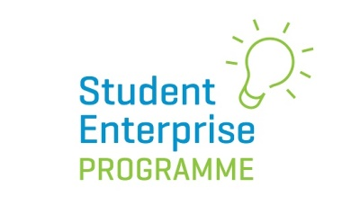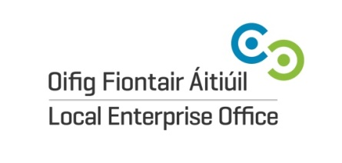

Dear _______________________

We are delighted to be able to tell you that your son/daughter is participating in this year’s Student Enterprise Programme, an enterprise initiative sponsored by the Local Enterprise Offices.

This is a big commitment but also a great opportunity to bring their ideas to life in a real life business where they also get to keep all of the financial rewards.

It is also a great learning curve and will give them valuable experience in:

- Being part of a team
- Earning and managing money
- Being involved in a National Competition – over 20,000 students take part every year
- Representing their school
- Doing something fun and creative

There is an excellent website you could look at which tells you all about it www.studententerprise.ie We have seen that with the support of their parents, children often far surpass their own expectations in this competition and we would encourage you to get involved and encourage their ongoing participation.

The Programme lasts for 6 months so that is a long time to maintain motivation!

Thank you for your support. We hope to see you at the County Finals!!

