My Entrepreneurial Plan

Step 1 – Resources – potential Learning Outcome & Key Concepts (with suggested activities)

1.1 Review the personal resources available to them to realise their needs and wants and analyse the extent to which realising their needs and wants may impact on individuals and society
Potential Key Skills in Focus:  - Communicating  - Being Literate  - Managing Myself  - Staying Well  - Management Information and Thinking | Potential Wellbeing Indicators in Focus:  - Responsible  - Connected  - Aware  - Respected  - Resilient

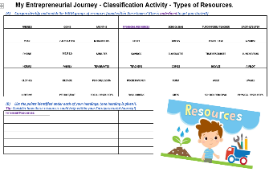
Some potential key concepts to assist you in being enterprising:

- What is a “resource”?
- What resources are available to you?
- Classification of resources – financial, social, physical? Insert resource type classification activity here
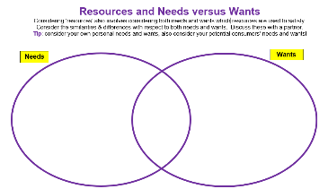
- How might these resources help you to be enterprising?
- What is meant by a “need” and a “want”? insert venn diagram needs v wants activity here)
- Have consumers various needs and wants?
- Concepts of both financial and opportunity costs?
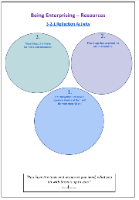
- Financial problem solving and decision making process?
- Impact of our decisions on other individuals – family, friends, wider community?
- Reflect on what you learned here: insert 3/2/1 reflection here)

